Standard Operating Procedure: Recruitment and Informed Consent
Recruitment Sources: Participants are patients who are admitted to general medicine units of Northwestern Memorial Hospital (NMH) under Inpatient Status. Participants include those who identify as having a disability and or require accommodation(s) for greater than 6 months. These general medicine units include Feinberg 15E, 15W, 16E, 16W, 13W, 13 E, and Prentice 13S (except beds 1381-1384 which are Oncology beds).
We aim to enroll 15-25 participants to complete this study. The staff-directed recruitment flyer will be distributed on the study units in staff spaces (e.g. nurses’ break room, physician work room) to aide in recruitment. The Electronic Health Record (EHR), EPIC, will be used as a method of recruitment to identify patients who are presently admitted to NMH that have one or more disabilities or accommodations documented in their EHR. Use of the EHR is permitted for recruitment in this study due to an approved “EDW Exception.”
Areas to search for documentation of disability/ability status via chart review on EPIC include:
- Disability Accommodations under patient demographics
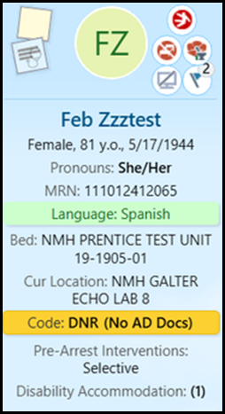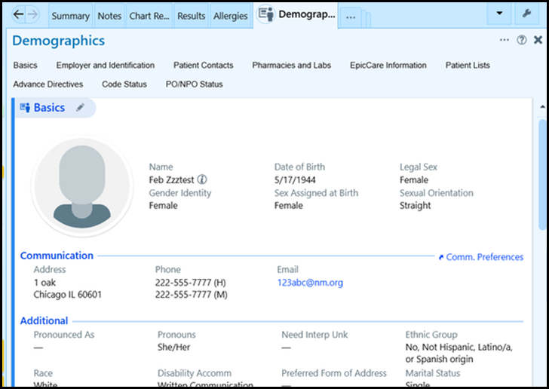

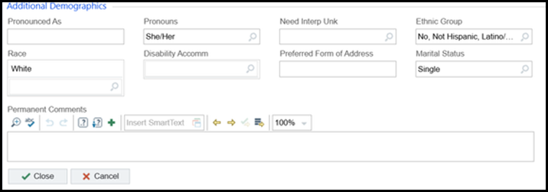
- Data Documented in “Getting to Know Me” under the “IPC-Interprofessional Plan of Care”
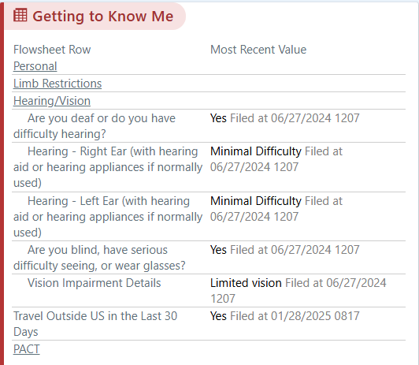
- Clinician Notes (Physician, Social Work, PT/OT, SLP, H&P, etc.)
- Nursing Handoff Sticky Note
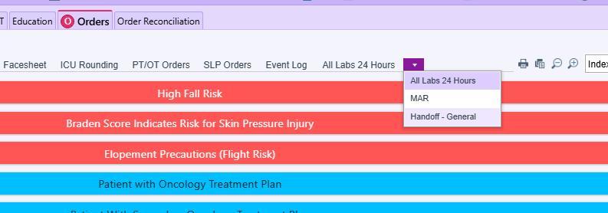

Study team members will also collaborate with members of the interdisciplinary care team of the inpatient general medicine units to identify patients who may have a disability or accommodation need that is not documented in the EHR that the team can approach for participation. The staff-directed flyer instructs staff to email the PI to notify the study team of potential participants.
Potential participants will be added to the “Disability Accommodations-Potential Participants” EPIC shared list, shared with study team members who are involved in recruitment, consent and data collection.

Participant Tracking/Document Storage:
Recruitment, enrollment, and study completion will be tracked in Microsoft TEAMS: Disability at NMH-LEAD Study Binder --> General--> Ongoing Study Folder--> Data --> Participant List and Study Tracking
Participant ID numbers will start with “PP” followed by consecutive numbers beginning with 1 (“PP1”). Once a potential participant is identified to be approached, they will be assigned an ID number, and recorded in the Participant List spreadsheet. Even if a potential participant declines to participate in the study, this will be recorded (including the reason why, if shared).

Enrollment Procedures:
Once a potential participant is identified, the PI or other team members will approach the patient in person, in their hospital room to describe the study and determine whether the participant would like to participate.
Be sure to bring a hard copy of the Consent form (2 versions), eligibility screener, and Short Blessed Test. We will introduce the key pieces of the study and complete the consent process.
- Introduce yourself and ask if this is a good time to speak with them on the opportunity to take part in a study.
Hello, my name is _____ from Northwestern Memorial Hospital’s Rehabilitation Department working with Dr. Lindsay Ardiff. I am here because we are conducting a research study focused on lived experiences of patients with disabilities in the hospital. Do you have a moment for me to explain the research study?

[If no]: Is there a better time when I can come back?

- Briefly explain the study and ask if you could review the different components of the study
If the potential participant needs accommodations like a sound amplifier, large text print, etc.; communicate with the PI to ensure we can provide accommodation for clear understanding.
The purpose of this study is to understand the experience of people with disabilities while they are admitted to the hospital. This study provides an opportunity for patients to share their experience on disability or accommodation related needs in the hospital, communication and interactions with the healthcare team, and accessibility of the physical hospital environment. Our goal is to help healthcare professionals and hospital administration to better understand the experience of individuals with disabilities in the hospital.

Do you have any questions so far?

Your participation in this study will take approximately 20-40 minutes and will involve an in-person private interview. This interview will take place here in your hospital room while you are admitted to the hospital with a member of our study team. The interview will be audio recorded and transcribed into text that can be analyzed by the research team. Your participation in this study is completely voluntary. Whether or not you participate, it will not affect your relationship, including healthcare services, with Northwestern Memorial Healthcare.

Do you think you would be interested in participating in this research study?

[If No]: Thank you for your time. May I ask the reason you do not think you would want to participate for our own study documentation purposes? Is there anything about the project I described that you are concerned about?

[If yes]: Thank you! The next step is for us to describe some more details about the study, go over the consent form, and have you sign the consent form. [BEGIN INFORMED CONSENT PROCESS].

Informed Consent:
The informed consent process will take place in person by one of the study team members, and the informed consent document will be provided and signed in person.
To conduct the consent process, all important components of the study and the informed consent document will be carefully reviewed by the team members.
Study team members should ensure they are speaking slowly and using lay language and will use long pauses to provide opportunities for processing information, ensuring proper communication, and asking questions.
Potential participants will be allowed as much time as they would like to discuss the study with the study members, healthcare providers, or their family members. Potential participants can choose to communicate with the team member to come back at a different time and may be given the research team’s contact information if they would like additional time to decide during their acute inpatient stay. The team member may also schedule a check-in time to complete the consent process at a later time.
When the participant is ready to sign the consent form, they will be able to do so by physically signing on page 8 of the consent form OR the witness of consent will sign under the Signature for Witness of consent Process if the participant is unable to sign the consent form.
ALL patients will receive a photocopy of their signed consent form.
The study team member will then continue to move forward with the interview or schedule a time to complete the interview (see SOP Recruitment_Eligibility_and Scheduling. The study team member will scan the consent form and should save the document to the study’s TEAMS folder:
TEAMS Login --> Channels --> Disability at NMH-LEAD--> General--> Shared -->Documents --> General --> Ongoing Study folder --> Participant List and Study Tracking --> Signed Consent Forms
The study member will then place the physical informed consent form under lock and key at: Prentice 15 Oncology Rehabilitation Office room 15-2319, accessible by the Principal Investigator and other study team members.

